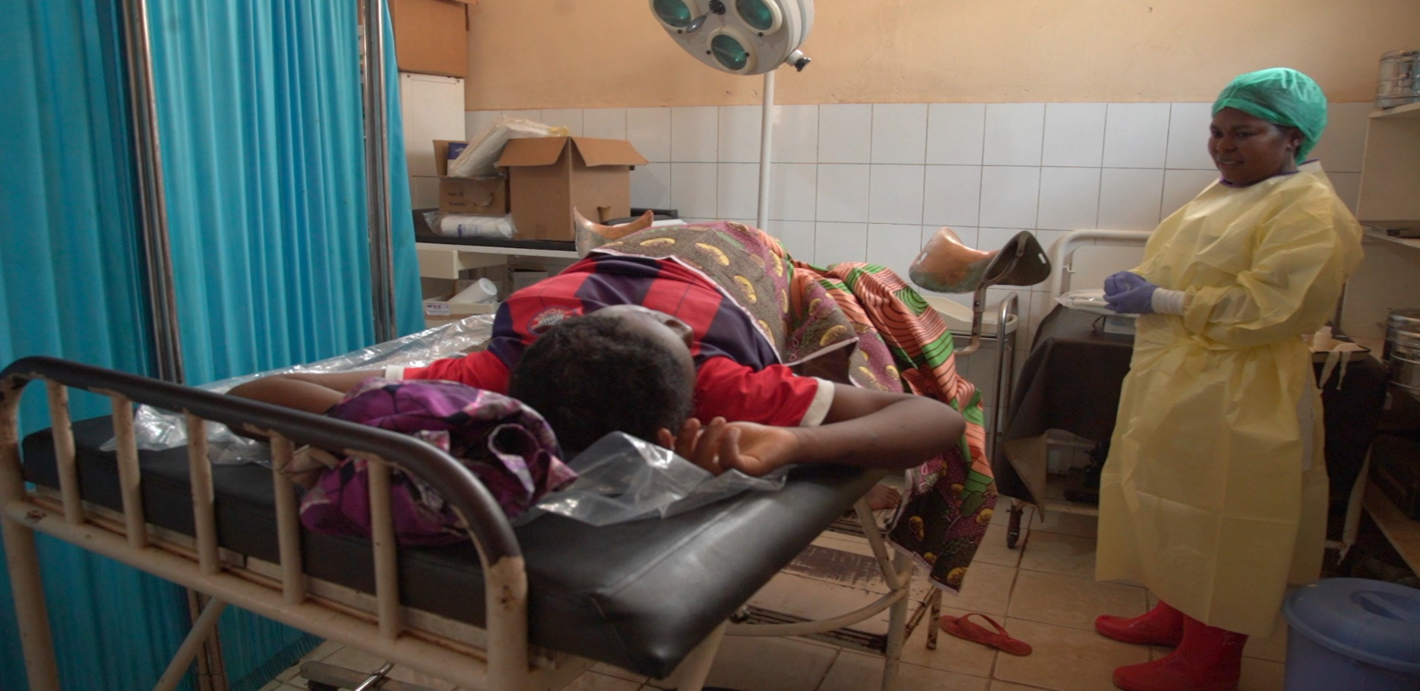


Key findings of a decade review of the HWF in the WHO African region, 2013 - 2022: implications for aligning investments to accelerate progress towards Universal Health Coverage.
Health Work Force (HWF) Team (HWF)
May 2024
Analytical
Fact Sheet

Rationale
With only seven years to 2030 SDG, reorienting health systems towards the primary health care (PHC) approach requires technical inputs from HWF. It is necessary to undertake a comprehensive desk assessment using available evidence to update the HWF situation in Africa. A snapshot of the health workforce (HWF) in the African Region for the decade 2013–2022 is presented by providing a thorough understanding of the situation of the region. It analyses stock and density; training and education capacities; migration; employment status; supply and demand; need for health workers; expenditures; leadership and governance; and impact of HWF levels across all 47 Member States and analyses key performance indicators against targets.

Key findings
- Data reporting across 47 countries increased from 26% in 2013 to 75% in 2019, and 81% in 2022 (HWF Cadre).
- 1.6 million in 2013 to 5.1 million in 2022 in HWF size.
- Positive HWF growth trajectory in 37 countries between 2018 and 2022.
- Eight countries increased HWF in numbers but were outpaced by population growth.
- Estimated 26.57% unemployment rate among skilled health workers (SDG 3.c occupations).
- 148,357 graduates in 2018 to over 255,000 in 2022 with a significant increase in health worker training output
- at least one health worker works abroad in every 10 workers in the region, around 42% of them intend to migrate, with the UK, US, Canada, Ireland, and Australia as top destinations.
- Funding commitments remain an issue although most countries have strategic plans and health workforce policies.

Background
Equitable access to competent health workers within resilient health systems is important to achieve Universal Health Coverage (UHC) in the context of Sustainable Development Goal 3 (SDG3). The Global Strategy on Human Resources for Health (GSHRH): Workforce 2030 is designed to accelerate progress by enhancing the availability, distribution, and capabilities of HWF. These are key components in delivering health services throughout the life course and during public health emergencies.
Significant progress has been made over the past two decades, in bridging critical health workforce (HWF) gaps. Training outputs have substantially increased, facilitating a rise in the HWF, and contributing to improvements in key health indicators, such as life expectancy and maternal and child mortality rates. However, the region continues to face challenges, underlined by its disproportionate global disease burden.
A significant effort has been made over the decades, HWF Milestones can be seen as follows,
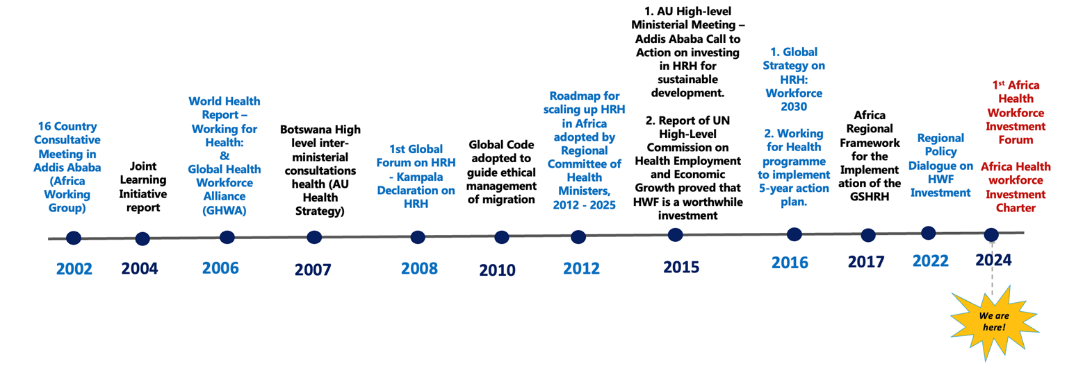
The findings are the result of triangulation and analysis of all available data and evidence from National Health Workforce Accounts (NHWA), Health Labour Market Analysis (HLMA) reports, and published literature on the HWF across the Region.

Brief Overview of concept and methodology
- The study used a three-step data triangulation approach, combining NHWA standards with other sources to address discrepancies. It ensures better data analysis across countries (see figure 1).
- Cross-sectional comparisons are applied from selected years (2013, 2018, 2022) to analyse health worker trends and distribution discrepancies.
- Adjustments for private sector contributions and different data sources, including HLMA reports and professional regulatory bodies, were made to provide a more comprehensive understanding of HWF dynamics.
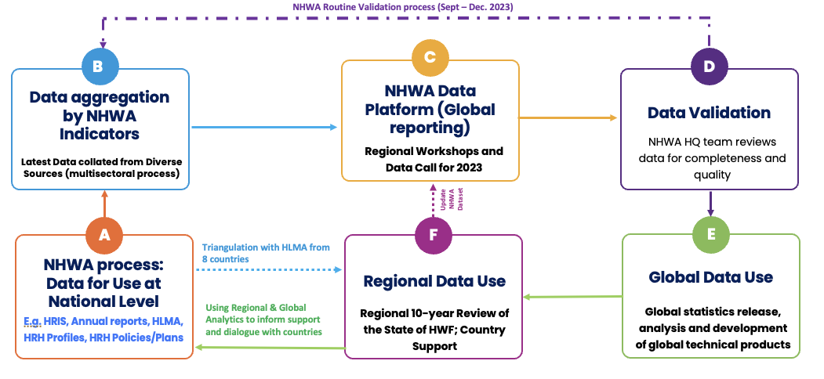
Figure 1: Approach to HWF data triangulation and use through NHWA

Key Findings
Data availability by number of occupations reported Increased from 26% in 2013 to 75% in 2018 and 81% in 2022. No countries reported all occupations in 2013, in 2018 only one country (Gabon) reported all the occupations while in 2022, three countries (Cameroon, Gabon, and Zimbabwe) reported all occupations.
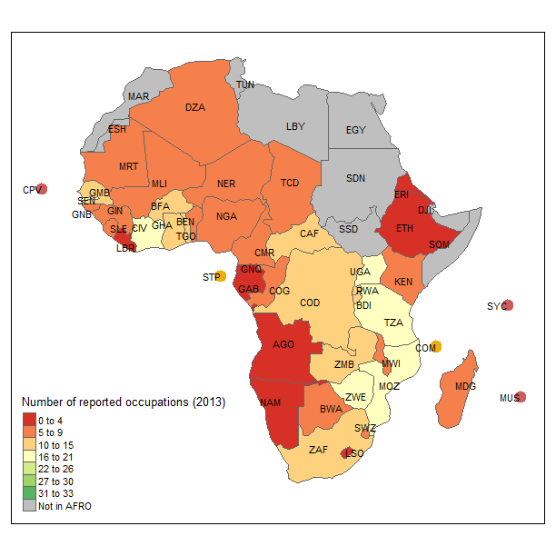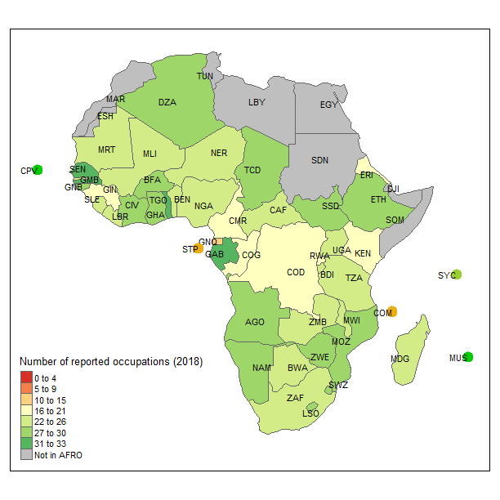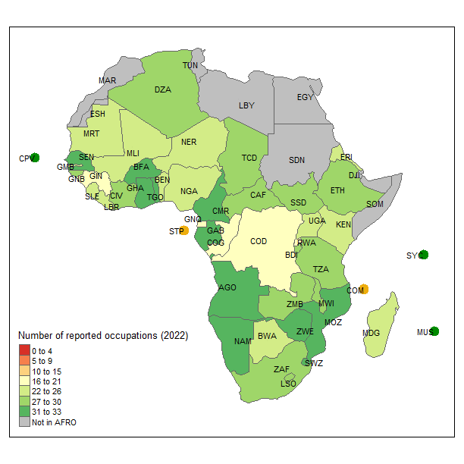
Figure 2: Data availability in the Region for 2013, 2018 and 2022

Regional Health Workforce Stock and Density
- In 2022, the African Region had approximately 5.1 million health workers, up from 4.3 million in 2018 and 1.6 million in 2013, tripling in number over nine years due to better data reporting and workforce expansion.
- The density of key health professionals (doctors, nurses, midwives, dentists, pharmacists) increased to 27 per 10,000 population in 2022, from 23 in 2018 and 11 in 2013.
- Seychelles, South Africa, and Namibia were the top countries while Niger, Central African Republic and Chad were lower quantile countries in SDG 3c HWF densities in 2022.
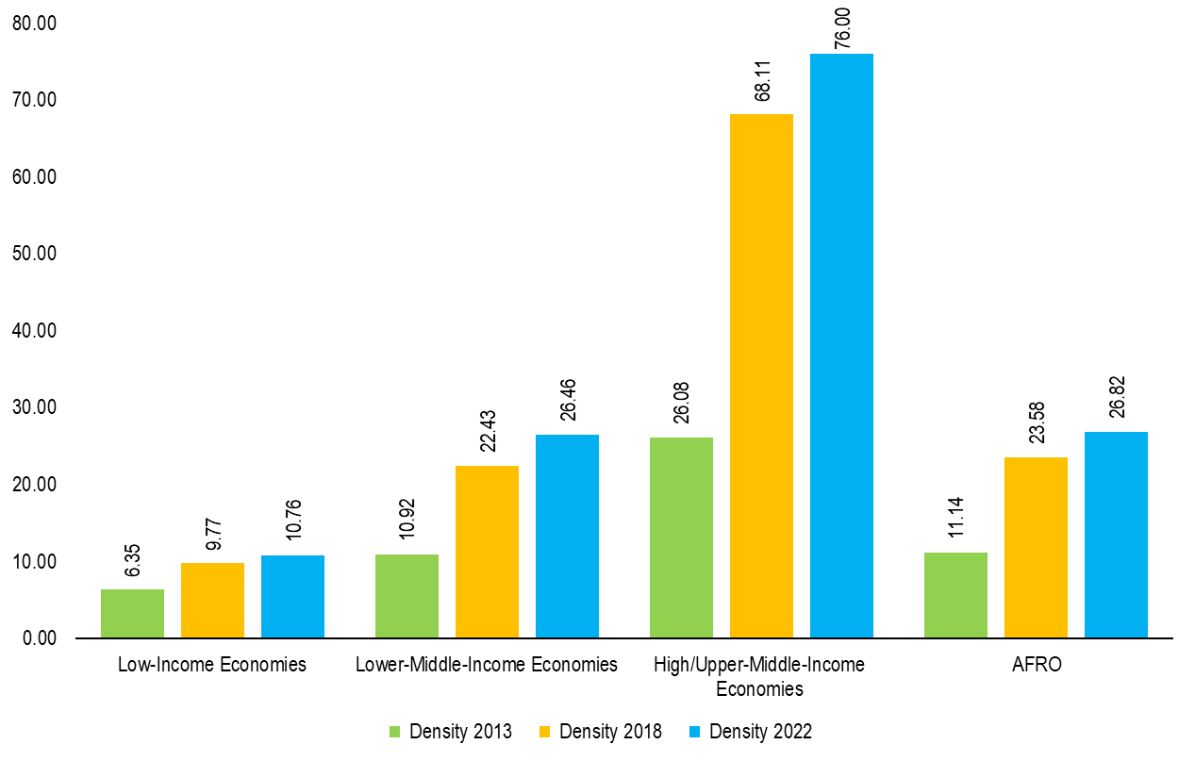
Figure 3: Density of doctors, nurses, midwives, dentists and pharmacists per 10,000 population with income groups
Medical Doctor
The density of medical doctors recorded a higher annual growth of 15.7%, compared to the stock, with a regional density of 1.44 in 2013 increasing to 5.33 per 10,000 population in 2022. The countries that recorded the largest increase in the density of medical doctors from 2013 to 2022 are Algeria, Angola, Cabo Verde, Comoros, Eswatini, Gabon, Namibia, South Africa, Seychelles, and Zambia. Conversely, the countries with the least improvement in medical doctor density during the same period are the Central African Republic, Côte d'Ivoire, Mauritius, Niger, and Gambia.
Nursing personnel
The nursing personnel stock in the African Region increased from 479 279 in 2013 to 1 698 828 in 2022, (nurses and their associate professionals) which is an annual increase of 15.1%. The countries with a decrease in their nursing personnel stock between 2018 and 2022 include the Central African Republic, Chad, Gabon, Gambia, Ghana, Guinea, Lesotho, Liberia, and Mauritius. The countries with the greatest improvement in nursing density from 2013 to 2022 are Angola, Algeria, Kenya, Gabon, Ghana, Namibia, Seychelles, South Africa, Zambia, and Zimbabwe. The countries with the least improvement in nursing density during the same period are Cameroon, Chad, Gambia, Guinea, and São Tomé and Príncipe.
Dentist
With an annual increase of 16% in the region, the countries with the most improved densities from 2013 to 2022 are Algeria, Cabo Verde, Eswatini, Eritrea, Lesotho, Mauritius, Namibia, Nigeria, and Seychelles. The countries with the least improvement are Côte d'Ivoire, Equatorial Guinea, Niger, South Africa, Togo, and Zimbabwe.
Pharmacist
The countries with the most significant improvement in density from 2013 to 2022 are Botswana, Ethiopia, Eritrea, Eswatini, Gabon, Ghana, Lesotho, Namibia, São Tomé and Príncipe, and Seychelles, while Benin, Cameroon, Côte d'Ivoire, Gambia, Mauritius, Senegal, and South Africa showed decreased trends.
Nurses and midwives
The countries with the highest increases in the stock of nurses and midwives from 2013 to 2022 are Algeria, Angola, DRC, Ethiopia, Ghana, Kenya, Nigeria, South Africa, Uganda, Zambia, and Zimbabwe. The countries with the highest increases in the density of nurses and midwives during the same period include Angola, Gabon, Ghana, Lesotho, Namibia, Seychelles, South Africa, Zambia, and Zimbabwe. the countries with the least improvement in density are Botswana, Cameroon, Gambia, Guinea, and São Tomé and Príncipe.
Sex composition
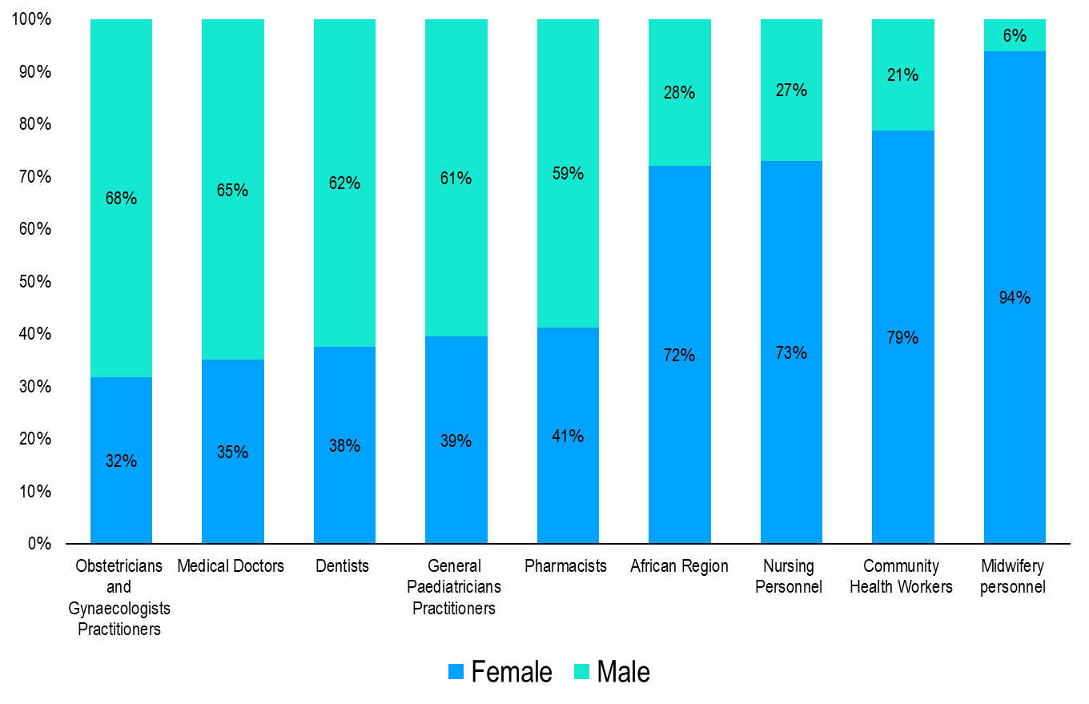
Figure 4: Sex composition for select occupations in the African Region
With data from 36 out of 47 countries, many health worker occupations are majority female. The SDG 3.c tracer occupations (doctors, nurses/midwives, dentists, and pharmacists) in the African region have more females (72%) than male (28%).
Distribution of the health workforce by age
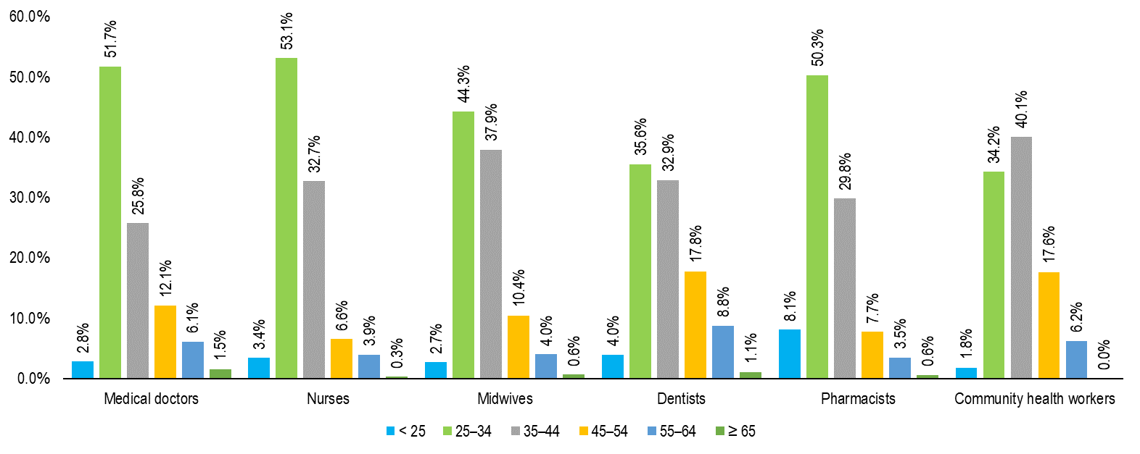
Generally, 82% of the workforce in the Region are below 45 years of age. Nurses have the highest composition (89%) of workers below 45 years of age, followed by pharmacists (88%), midwives (85%), medical doctors (80%), community health workers (76%) and dentists (72%).

HWF education, training, and accreditation
- The annual production of health worker graduates increased by over 70%, from 148,357 in 2018 to more than 255,000 in 2022. 71% of these training outputs are focused on producing doctors, nurses, and midwives.
- Regarding health training institutions, 4,000 HWF training entities (including semi-autonomous campuses and programmes within institutions), of which the private contributes 44%. 1 in 5 health science students who complete their programme of education do not pass the requisite licensing examination the first time.
- The median cost of training a medical doctor in the Region is US$ 10 572, but it ranges widely from US$ 5 106 to US$ 32 000.

HWF migration
- For every 10 doctors or nurses in the African Region, at least one is working abroad. The COVID-19 pandemic accelerated the out-migration of these health workers to high-income countries.
- During an exploratory HLMA, 9,102 health workers from six countries (Eswatini, Ghana, Kenya, Mozambique, Zambia, and Zimbabwe) were surveyed about their migration intentions. The results showed a range from 35% of Zambian workers to 63% of Ghanaian workers planning to migrate in the future.

Projections of HWF stock and need-based requirement, 2022 and 2030
- An estimated 2 million additional health workers are expected to join the Health Workforce (HWF) in the African Region from 2022 to 2030, with 75% of these being doctors, nurses, midwives, pharmacists, and dentists.
- In 2022, the African Region required 9.75 million health workers, including community health workers, to meet disease burden and population health needs. This number is projected to increase to 11.82 million by 2030. Excluding community health workers, the region needed nearly 8.7 million health workers in 2022 and will require approximately 10.6 million by 2030.
- the correlation between the HWF Need Availability Ratio (NAR) and UHC attainment, showing a strong correlation (r = 0.73) and explaining approximately 53% of the variation in UHC Service Coverage Index (SCI) scores across African countries in 2021. It highlighted the potential of needs-based HWF estimates to support at least 60 out of 100 UHC SCI scores across all countries.

Investments needed in HWF: implications for optimising budget space
In 2022, a significant funding gap in HWF, with only US$20.85 billion, or 57%, of the required US$36.3 billion available. It was received from domestic resources, the private sector, and external development assistance.
The funding gap to employ all trained health workers was 43%. These funding estimates have remained unchanged since a similar analysis in 2022 for East and Southern Africa.

Capacity for HWF governance, planning and management
All 33 responding countries have HWF units in MoH. 97% (32 countries) have HWF heads in senior management roles. Only 77% (25 countries) have decentralized HWF units at sub-national levels.
Most countries have HWF policies (80%) and strategic plans (63%) in place, but half (50%) have no commitment to increase budget allocation to implement HWF strategic plans.
Nearly 4 out of 10 countries reported a lack of intuitional models and norms for assessing staffing needs approaches to HWF projections and planning.
Most countries have costed their strategic plans. Nearly half of the countries have never conducted a health labour market analysis.
Only 1 in 3 countries have prioritised in their strategic plans to address health worker migration.

Exploring the relationship between the health workforce and key indicators
A strong correlation (Spearman’s rho = 0.74, p-value = 0.000) between per capita health expenditure and workforce density for SDG 3.c tracer occupations; similar trends are observed with other HWF investment metrics such as the percentage of domestic general government health expenditure and domestic health expenditure relative to Current Health Expenditure (CHE).
Increased health investment correlates with significantly enhanced workforce densities.
Countries with higher densities of health workforce (HWF) in SDG 3.c occupations show better health service coverage.
The analysis provides strong correlations between high HWF density and several health service metrics: service capacity and access (Spearman’s rho = 0.721, p-value = 0.000), non-communicable diseases (NCDs) detection capacity (Spearman’s rho = 0.407, p-value = 0.004), reproductive, maternal, newborn, and child health (RMNCH) services coverage (Spearman’s rho = 0.664, p-value = 0.000), and communicable diseases service coverage (Spearman’s rho = 0.298, p-value = 0.042).
These strong workforce densities correlate with improved quality of life, as indicated by higher healthy life expectancy.

Recommendation
- Expanding health workforce education, decent employment and ensuring retention towards halving the needs-based shortage within a decade
- Transforming HWF education to be competency-based to better address population health needs.
- Leveraging multisectoral action to implement the principles of the Africa HWF investment charter towards expanding and sustaining adequate investments in the HWF.

References
WHO, a decade review of the HWF in the WHO African region, 2013 - 2022: implications for aligning investments to accelerate progress towards Universal Health Coverage, 2024.

Sources
The Integrated African Health Observatory supported the production of the factsheets.
Photography: © WHO/Grainee Harrington
Location: Goma, Democratic Republic of the Congo
Check out our other Fact Sheets in this iAHO country health profiles series:
https://aho.afro.who.int/country-profiles/af
Contact us at: iAHO@who.int

Connect with us on LinkedIn: https://www.linkedin.com/company/iaho/

The fact sheet was produced by Wai Phyo Thant,

